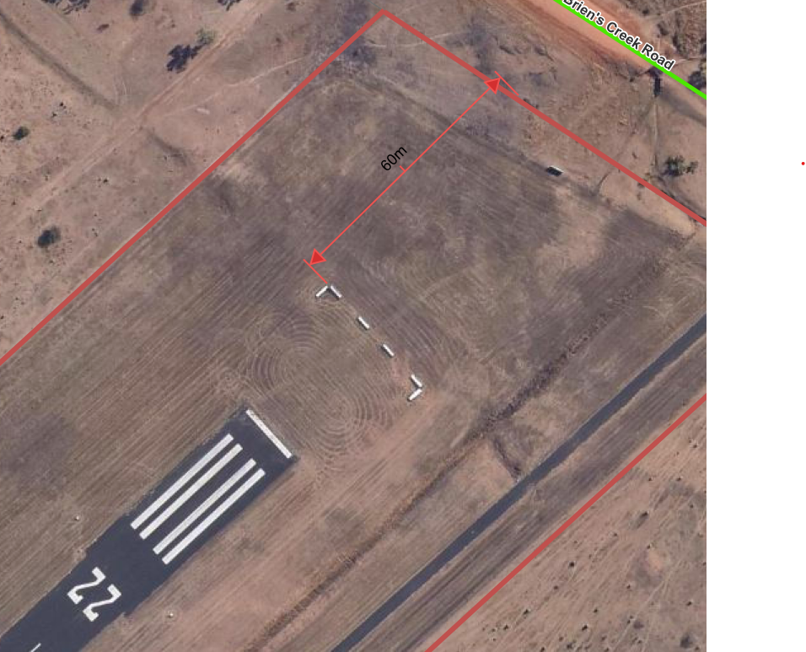

22 end of the Mount Surprise Air Strip

04 End of the Mount Surprise Air Strip

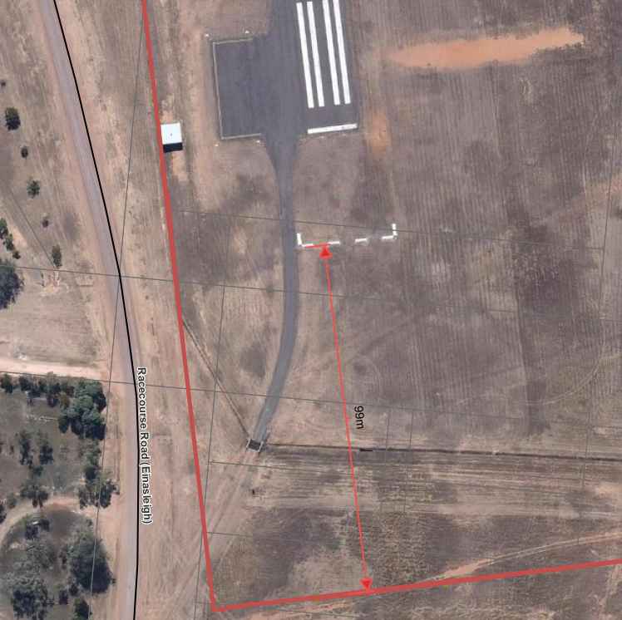

35 end of the Einasleigh Surprise Air Strip

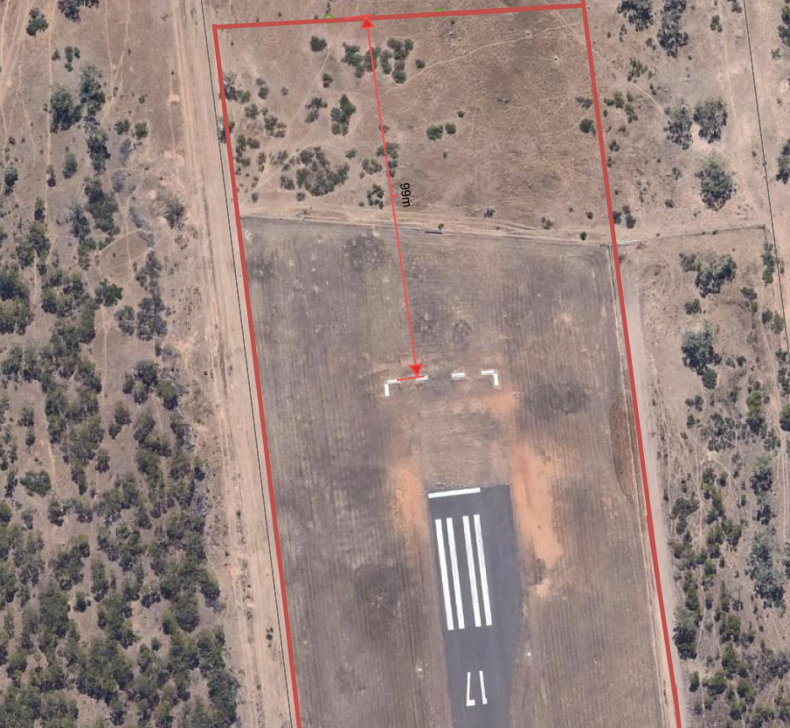

17 end of the Einasleigh Surprise Air Strip